The Blockchain Association Communications Response Plan
Introduction
The Blockchain Association has sought Peters Communications counsel on repairing the reputational damage the cryptocurrency industry has sustained due to the recent intense crisis surrounding FTX and subsequent well-publicized scrutiny of the company’s disintegration in the media.
This communications response plan offers several recommendations designed to stem the flow of reputationally damaging information, prevent further credibility hemorrhaging and postpone and prepare for any future oversight and investigation from the public, Congress, industry and financial regulators, and a broad array of stakeholders, with the eventual aim of sustainability and renewal.
Section I provides a situational overview and topline analysis of how the cryptocurrency industry’s reputation has been impacted to date and what the situation looks like today. Section II outlines strategic imperatives to inform this reputation recovery plan and includes key messages to achieve this desired outcome. Section III details an example expected question and model answer plan to prepare key communicators at The Blockchain Association to communicate effectively with the numerous involved stakeholder groups and address their concerns. Section IV details a specific, concrete tactical action with associated resources: a Twitter campaign and an advertisement graphic for use in social media posts and traditional media ads.
In summary, this plan should serve as the foundation for a long-term communications strategy as The Blockchain Association looks to stabilize and restore the cryptocurrency industry’s reputation amid recent debilitating credibility crises and provides substantive action steps to win back the trust of key stakeholders for your members.
Section I
Situational Overview + Topline Analysis
The collapse of FTX, one of the world's largest cryptocurrency companies, continues to make waves throughout the industry and the global financial system. Sam Bankman-Fried’s mismanagement of his the at-peak $32 billion cryptocurrency company has shone a glaring spotlight of public scrutiny on the cryptocurrency industry, with potentially devastating impact for the 100 members The Blockchain Association represents. FTX disintegrated practically overnight after it could not meet a run on withdrawals that left the company with an $8 billion hole in its accounts. Within a week, the crypto exchange filed for bankruptcy. Traders have lost billions of dollars they stored on the platform, and companies with ties to FTX have also found themselves on shaky financial footing. FTX is currently engaged in bankruptcy proceedings and could owe money to more than a million people and organizations.
Treasury Secretary Janet L. Yellen called FTX's collapse a "Lehman moment" for the cryptocurrency industry, referring to the bankruptcy of the Wall Street bank Lehman Brothers at the start of the 2008 financial crisis. Commodity Futures Trading Commission Chairman Rostin Behnam has said, "Lawmakers should pass legislation that would impose strict rules on cryptocurrency exchanges." FTX's collapse is a pivotal upheaval that impacts general trust in the cryptocurrency industry, a space already experiencing a "winter" period as prices shake and confidence is rattled. Valuations for currencies like Bitcoin or Ethereum are no longer anywhere near their peak and the industry is experiencing a sustained decline that has seen the market lose more than $1 trillion in value from this time a year ago. Moreover, since the implosion, several other major crypto firms have come under mounting financial pressure as fears grow that the collapse could cause other companies to fail.
The cryptocurrency industry begins on the back foot in the contest for public opinion because it is fundamentally misunderstood. Flare ups like FTX’s meltdown only serve to add to this confusion and damage the industry’s reputation through an association with chaos. The predominant criticisms leveled at the cryptocurrency industry as a result focus on this previous sloppy administration and corporate mismanagement. It is symbolic and unpredictability and unreliability are at the forefront of people's perceptions of the cryptocurrency industry. From a bird's eye perspective, the cryptocurrency industry appears close to breaking point, with shaky investor confidence and the likelihood of stricter federal regulation on the horizon. These factors pose a significant challenge to The Blockchain Association’s prospects.
However, when at the lowest point, there is only one way things can improve. By utilizing this plan, the outlook will quickly become more favorable from a reputational standpoint, benefitting the Blockchain Association by establishing it as the preeminent thought leader among its members and an organization trusted to lead the cryptocurrency industry's reputation recovery and renewal.

Section II
Strategic Imperatives
The central objective of this communications response plan is to put The Blockchain Association on a sure footing to work with its members to rebuild the reputation of the cryptocurrency industry quickly. To this end, Peters Communications believes there are certain strategic imperatives around which The Blockchain Association must focus all its tactical communication actions:

- Shift the narrative away from recent failures, acknowledge the mistakes of bad actors and emphasize the need to reshape the industry’s priorities.
The current atmosphere surrounding cryptocurrency is toxic and corrosive. Yet this presents the industry with an opportunity to reshape. Rebuilding must be the focus and shifting the narrative away from negativity will be critical. By explaining and acknowledging the mistakes of individual bad actors and distancing them from the industry as a whole, The Blockchain Association can lead from the front on radically altering the industry’s perception among the public and create a more fertile space for the enactment of reform and redevelopment of its reputation.

- Embrace regulation and prepare and educate the Blockchain Association’s members for it

The Blockchain Association is growing in membership and lobbying capability due to its renowned expertise in dealing with Capitol Hill. Having a voice in the upcoming regulatory discussions will be vital for the industry and the Blockchain Association is ideally placed to lead this conversation by being an advocate on policy. Many of the association’s members are generally part of startups or relatively new to the space and do not have the internal resources for analysis and navigation of government regulation. Now is the time to display these credentials and act, encouraging oversight and working with the federal government to carve out a different but equally rewarding and more sustainable future for the industry. This bold move will attract more members desperate for strategic guidance at a time when the industry as a whole is on a knife’s edge.

- Enact a form of social contract with stakeholders over deliverable improvement measures.
By restating a focus on new corporate values among The Blockchain Association’s members and cryptocurrency industry leaders, you will be able to develop a new and improved reputation as an established corporate body focused on ethics and counteract the industry’s misplaced reputation for playing fast and loose with financial regulations. These values should include Sustainability, Security and Stability. Moreover, The Blockchain Association should make it clear to its members that as a condition of association, they must be prepared to be held to account over these values and position all corporate strategies to be informed by their necessary expectations.

- Position The Blockchain Association as a leading figure in the cryptocurrency industry and define the broader debate and implications for the community moving forward.
The Blockchain Association must emphasize its role as a leading light and guiding compass as a central thought leader in cryptocurrency. By returning to the industry’s founding ideals of revolution, bravery and innovation, coupled with a refocusing towards corporate legitimacy and regulation-based, clean business practice, The Blockchain Association will be able to light a clear, positive path towards a more rewarding future away from recent charges of malpractice and illegality.

Key Messages
Several well-defined key messages regarding The Blockchain Association’s goals of leading from the front in repairing the cryptocurrency industry’s reputation and shaping its future, with supporting rationale, should reinforce these strategic imperatives to inform your specific communication actions. Peters Communications recommends the key messages include:

- Our members are committed to an open and ethical way of doing business. Your money is our responsibility.
The Blockchain Association must emphasize transparency and responsibility as fundamentals to the industry’s mission moving forward. Its members should embrace regulatory oversight and open the books, as Uber successfully did. We want to emphasize that the company is willing, able, and excited to start again from a reputational base camp, working hard every day. The Blockchain Association will need concrete action to accompany this key message. While Peters Communications advises outside expert counsel in the technical intricacies of the industry be brought in, we do suggest one such example of a concrete step for reference: The Blockchain Association should enact a version of FDIC insurance that is in place with banks, which protects savers in the event their bank goes under. To do so, The Blockchain Association should require as a condition of membership in its association that each cryptocurrency-owning individual or organization contributes a monthly or annual fee decided based on the size of their assets to an independently held and governed contingency fund in order that investors have an increased level of confidence and security in the event of company collapse or cyber attack theft. This would hugely increase the levels of trust and collaboration among investors in the industry and promote cooperation among its organizations as a way to build towards a more sustainable future.

- Cryptocurrency is a revolutionary innovation. Its success story stems from a willingness to go beyond, do the unexpected, and challenge the status quo.
This key message allows The Blockchain Association to convey that operating at the edges of an established financial system that serves the few, not the many, should be welcomed, not shunned. Cryptocurrency comes with a certain amount of risk. Let customers know you must be brave to be the best. The cutting-edge nature of cryptocurrency inherently requires a willingness to be courageous and adopt some risks. This message will also appeal to the less risk averse, younger, cash wealthy demographic integral to resurrecting cryptocurrency’s growth through new and additional investment.

- The Blockchain Association is not responsible for the actions of individual companies like FTX.
FTX’s failure as a result of the well-publicized issues mentioned above and the misguided leadership of Sam Bankman Fried had nothing to do with The Blockchain Association and its more than 100 members. While the original ideals of cryptocurrency remain alive and well in the industry, the malpractice of individual actors is not. The Blockchain Association’s leadership and decision-making structure and that of its members are staffed by much safer pairs of hands, with a wealth of experience. This kind of distancing and separation should be present across your communications.

- The cryptocurrency industry is experiencing a broader downturn, but The Blockchain Association is restructuring and intent on renewal.
Our initial analysis suggests The Blockchain Association should place the current disastrous situation surrounding FTX into a rational context and stay calm. Cryptocurrency may be less lost in the court of public opinion per our assessment than many believe. More smoke will have to clear from the wreckage of FTX before any consensus can form, despite its impact in the court of public opinion. Many will believe that the collapse of FTX underscored the risks of crypto investing and the prudence of keeping the rest of the financial system insulated from the industry, at least in its current form. However, companies in the industry have experienced meltdowns before, which has not killed it. On the contrary, the cryptocurrency industry has gone from strength, managing an estimated 3 trillion dollars’ worth of assets earlier this year. Plenty of people hold strongly favorable views about crypto that remain unaffected by the collapse of FTX. And despite crypto investing's reputation as a high-risk endeavor, the attitude of the majority has been to shrug, having witnessed no substantive impacts on global markets and remain calm. The Blockchain Association’s response should keep with this sentiment and not shoot itself in the foot with a detrimental defensive crouch overreaction to FTX’s collapse.

Section III
Q&A
This Q&A details an example expected question and model answer plan to prepare key communicators at The Blockchain Association to address the concerns of and communicate effectively with the numerous involved stakeholder groups. We envision these key communicators as the CEO and the communications lead, and these would be our preferred figures taking these questions and leading from the front. The key stakeholder groups included are the media, industry financial regulators and Congressional oversight and investors and The Blockchain Association members. This Q&A will serve as a primary tool for engagement in the next few days and weeks. However, Peters Communications will follow up with an additional, more comprehensive media training for lead communicators shortly.

- Media
  - What is your response to the current situation with FTX? The Blockchain Association understands the concerns raised by many about the corporate malpractice charges leveled against FTX and its founder and former CEO, Sam Bankman-Fried. We are keen to stress our shock at these charges and our willingness to see a full and proper investigation of what has occurred in FTX’s fraudulent mishandling of thousands of investors’ assets. As we have repeatedly asserted, The Blockchain Association has nothing to with and is in no way related to FTX. The Blockchain Association is a significantly different organization, with a focus on transparency, innovation, and equality. We hope the ongoing lawsuit closes a sad and isolated chapter in the cryptocurrency industry’s history, allowing our many excellent members to achieve our mission of reform and renewal, and we will certainly be working every hour of every day to make this a reality for our stakeholder community.
  - How is The Blockchain Association different from FTX, an illegal omnishambles of a company? FTX made significant, damaging mistakes. However, The Blockchain Association is a significantly different organization, with a focus on transparency, innovation, and equality. FTX was a cryptocurrency exchange body directly profiting off handling asset investments and transfers. Whereas, The Blockchain Association is an advocacy group for over 100 cryptocurrency organizations, a collective voice promoting the future of the industry and shaping policy through education to ensure its success. Cryptocurrency revolutionized our world. But industry members have made mistakes. Now, the Blockchain Association is leading a laser-focused push for evolution. Crypto has listened and learned, and we're back and better than ever. And there's still so much we can achieve. Together.
  - How will the Blockchain Association ensure an “FTX” never happens again? The Blockchain Association have encouraged our members to join our pledge and initiate a set of corporate values centered around Sustainability, Security and Stability, to which they will position all investment and corporate strategies to ensure all decisions are informed by their necessary expectations. These values will be broadly publicized in the coming days and weeks with the support of The Blockchain Association’s communications campaign, allowing our members to open a social contract and begin a dialogue with their stakeholders, solidifying their commitments to transparency and responsibility moving forward. We will encourage our members to expect to be judged on their actions and not their words and we are prepared to foster a community of being held to account over these values. They are not empty promises. The Blockchain Association and our members are laser-focused on evolving. Another step The Blockchain Association and our members will take is to enact a version of FDIC insurance that is in place with banks, which protects savers in the event their bank goes under. To do so, The Blockchain Association will require as a condition of membership in its association that each cryptocurrency-owning individual or organization contributes a monthly or annual fee decided based on the size of their assets to an independently held and governed contingency fund in order that investors have an increased level of confidence and security in the event of company collapse or cyber-attack theft. This will hugely increase the levels of trust and collaboration among investors in the industry and promote cooperation among its organizations as a way to build towards a more sustainable future for cryptocurrency and avoid repeating the mistakes of the past.

- Industry Financial Regulators and Congressional Oversight
  - Why should anyone trust cryptocurrency companies that make up your membership with their assets in the future, given the FTX disaster? As we have repeatedly asserted, the Blockchain Association has nothing to with and is in no way related to FTX. The Blockchain Association is a significantly different organization, with a focus on transparency, innovation, and equality. We will be working alongside our many excellent members to support them in achieving our mission of reform and renewal in the cryptocurrency industry, and we will certainly be working every hour of every day to make this a reality for our stakeholder community. While cryptocurrency’s founding ideals of innovation and financial revolution remain, the malpractice of rogue actors has no place in The Blockchain Association. Our members are willing to go beyond, do the unexpected, and challenge the status quo. But they are also committed to an open and ethical way of doing business. The two are connected and collaborate in throughout all corporate structures in The Blockchain Association’s network.
  - How does The Blockchain Association assess the future of cryptocurrency in our world? The recent disintegration of FTX was due to its profoundly flawed organizational structure and the significant, damaging mistakes of individual actors. But that reflected on individuals and their associated corporate malpractice, not the industry itself. In 2008, the banks caused a global recession amid a housing crisis that plunged millions of Americans into poverty. But they were bailed out at the cost of billions of dollars of taxpayer money. So why this hyper-scrutinized focus on a cryptocurrency industry that continues to go from strength to strength, managing an estimated $3 trillion worth of assets earlier this year? Everyone here today knows the answer to that. Cryptocurrency’s willingness to operate at the edges of an established, entrenched and deeply flawed financial system that serves the few, not the many, should be welcomed, not legislated against. The industry was founded on revolutionary innovation. Its success story stems from a willingness to go beyond, do the unexpected, and challenge the status quo. The cutting-edge nature of cryptocurrency inherently requires a desire to be courageous and adopt some risk. Plenty of people hold strongly favorable views about crypto that remain unaffected by the recent high-profile collapse of FTX. The attitude of the majority has been to shrug, having witnessed no substantive impacts on global markets and remain calm. The Blockchain Association encourages folks here on Capitol Hill to do the same.
  - How does the Blockchain Association and its members plan to restore confidence in the cryptocurrency industry and rebuild its reputation? The Blockchain Association have encouraged our members to join our pledge and initiate a set of corporate values centered around Sustainability, Security and Stability, to which they will position all investment and corporate strategies to ensure all decisions are informed by their necessary expectations. These values will be broadly publicized in the coming days and weeks with the support of The Blockchain Association’s communications campaign, allowing our members to open a social contract and begin a dialogue with their stakeholders, solidifying their commitments to transparency and responsibility moving forward. We will encourage our members to expect to be judged on their actions and not their words and we are prepared to foster a community of being held to account over these values. They are not empty promises. The Blockchain Association and our members are laser-focused on evolving. Another step The Blockchain Association and our members will take is to enact a version of FDIC insurance that is in place with banks, which protects savers in the event their bank goes under. To do so, The Blockchain Association will require as a condition of membership in its association that each cryptocurrency-owning individual or organization contributes a monthly or annual fee decided based on the size of their assets to an independently held and governed contingency fund in order that investors have an increased level of confidence and security in the event of company collapse or cyber-attack theft. This will hugely increase the levels of trust and collaboration among investors in the industry and promote cooperation among its organizations as a way to build towards a more sustainable future for cryptocurrency and avoid repeating the mistakes of the past.
- Investors and The Blockchain Association Members
  - Why should we continue to invest our assets with your members and not take our money elsewhere after the recent crypto scandals and controversy? Cryptocurrency revolutionized our world. But mistakes were made. Now, our members have listened and learned, and we're back and better than ever. There's still so much we can’t achieve. Together. The Blockchain Association have encouraged our members to join our pledge and initiate a set of corporate values centered around Sustainability, Security and Stability, to which they will position all investment and corporate strategies to ensure all decisions are informed by their necessary expectations. These values will be broadly publicized in the coming days and weeks with the support of The Blockchain Association’s communications campaign, allowing our members to open a social contract and begin a dialogue with you, their investors, solidifying their commitments to transparency and responsibility moving forward. We will encourage our members to expect to be judged on their actions and not their words and we are prepared to foster a community of being held to account over these values. They are not empty promises. The Blockchain Association and our members are laser-focused on evolving. Another step The Blockchain Association and our members will take is to enact a version of FDIC insurance that is in place with banks, which protects savers in the event their bank goes under. To do so, The Blockchain Association will require as a condition of membership in its association that each cryptocurrency-owning individual or organization contributes a monthly or annual fee decided based on the size of their assets to an independently held and governed contingency fund in order that you, our investors, have an increased level of confidence and security in the event of company collapse or cyber-attack theft. We hope this will help to ease understandable concerns based on the past actions of rogue and criminal individuals and increase the levels of trust and collaboration among investors in the industry, promoting cooperation among its organizations as a way to build towards a more sustainable future for cryptocurrency and avoid repeating the mistakes of the past. Our members are committed to this open and ethical way of doing business. Your money is their responsibility.
  - The cryptocurrency industry is obviously experiencing a downturn. Why shouldn’t we just cut our losses with crypto and invest our money in safer, more traditional industries? The Blockchain Association’s members are laser focused on restructuring and renewal and learning from the mistakes of the past, and we would refer you to our previous answer on how we plan on doing that. However, The Blockchain Association encourages all cryptocurrency investors to place the current disastrous situation surrounding FTX and its impacts on the general atmosphere and lack of confidence around cryptocurrency into a rational context and stay calm. Cryptocurrency may be less lost in the court of public opinion per our assessment than many believe. More smoke will have to clear from the wreckage of FTX before any consensus can form, despite its impact in the court of public opinion. Many will believe that the collapse of FTX underscored the risks of crypto investing and the prudence of keeping the rest of the financial system insulated from the industry, at least in its current form. However, as you know companies in the industry have experienced meltdowns before, which has not killed it. On the contrary, the cryptocurrency industry has gone from strength, managing an estimated 3 trillion dollars’ worth of assets earlier this year. Plenty of people hold strongly favorable views about crypto that remain unaffected by the collapse of FTX. And despite crypto investing's reputation as a high-risk endeavor, the attitude of the majority has been to shrug, having witnessed no substantive impacts on global markets and remain calm. The Blockchain Association encourages that our members and all involved stakeholders should share in this sentiment and not shoot themselves in the foot with a detrimental defensive crouch overreaction to FTX’s collapse and act too hastily to mitigate any broader impacts it may have had on the industry or investments before all the facts are known and consequences understood.

Section IV
Specific, Concrete Tactical Action Resources
The resources included in this section are specific actions crafted using the communication response plan's strategic imperatives and incorporating key messages. The Blockchain Association should utilize these resources to help improve the industry’s reputation and assist its members with their own reputation management processes. Both are focused on maximizing their potential reach in the digital age and enhancing the Blockchain Association’s ability to access your most target demographics more readily in terms of the highly online, highly active predominant stakeholders involved in, engaged with, and interested in the cryptocurrency industry. Peters Communications is willing to be on retainer moving forward with The Blockchain Association, ready and able to assist any individual member with their own targeted communications response plan.

- Promotional Graphic
This promotional graphic will form the basis of an advertising campaign in the next month focused on heralding a new dawn for cryptocurrency and marking a significant change in the industry’s leadership, structure, and outlook. Peters Communications will incorporate it in media buys for advertisements across the online space: newspaper sites such as The New York Times and The Wall Street Journal, email newsletters such as Politico and Bloomberg Business, and a wide range of social media advertising opportunities, including Instagram and Snapchat. This advertisement graphic fits the strategic imperatives framework we previously developed as it will reintroduce a new and streamlined cryptocurrency industry that has acknowledged and learnt from the mistakes of the industry’s rogue actors into the consciousness of our highly online and corporate target demographic in the spaces that shape their everyday thoughts and impressions. This will allow The Blockchain Association to shift the narrative for its members away from recent failures and current litigation by heralding a new dawn and positioning it as a leading figure in the cryptocurrency industry, defining the broader debate and implications for the community moving forward.
----------

- Twitter Campaign
A Twitter campaign will allow The Blockchain Association to shape the cryptocurrency industry’s narrative for its members in a critical informational and perception development space. Despite recent controversies regarding hate speech, Twitter remains a top-rated, important platform in the news and information space. Analyzing trends on the platform by monitoring conversations and other tools provides us with a high-level overview of social listening, sentiment intelligence and forecasting information. As a tool, its utility in shaping dialogue cannot be overstated. This route allows us also to use Twitter analytics to provide real-time, data-informed insights. Again, this tactical action is targeted at reintroducing a new and streamlined cryptocurrency industry into the consciousness of our highly online and corporate target demographic in the spaces that shape their everyday thoughts and impressions, shifting the narrative away from recent failures and current litigation by taking responsibility and emphasizing transparency and positioning The Blockchain Association as a leading figure in the cryptocurrency industry, defining the broader debate and implications for the community moving forward. Some tweets hyper-focused on our strategic imperatives and utilizing the key messages we have developed are included here for your review. These will be published regularly in the coming days and weeks to totalize The Blockchain Association’s engagement and impact on the platform. As well as the below examples, other content options include retweeting favorable online content such as articles, publicizing favorable quoted testimony from The Blockchain Association’s members and other avenues for promoting content such as clips from press conferences and video endorsements from stakeholders involved in cryptocurrency promoting the industry’s new brand and adding weight to your key messages with personal accounts.

----------
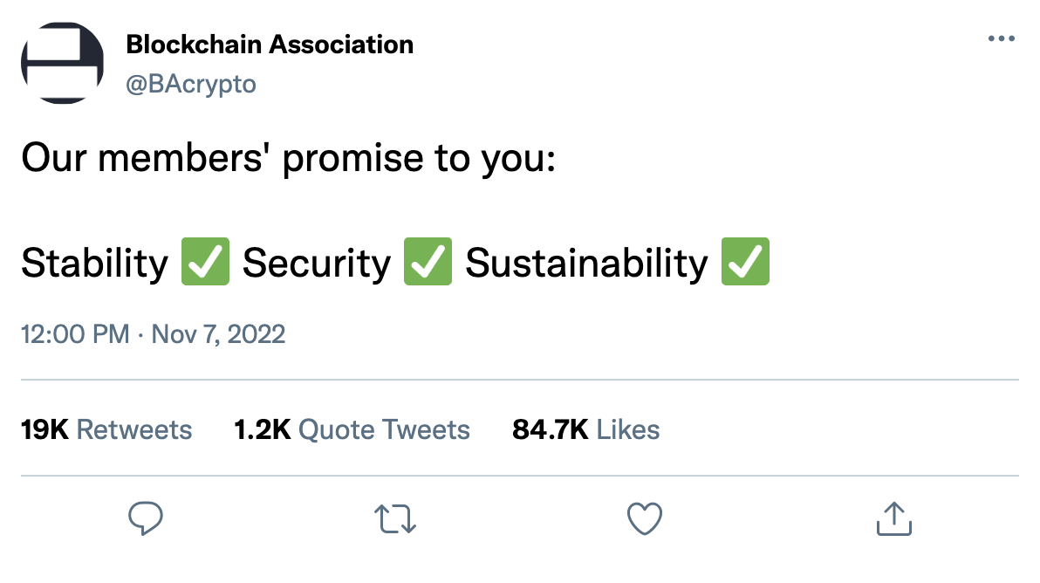
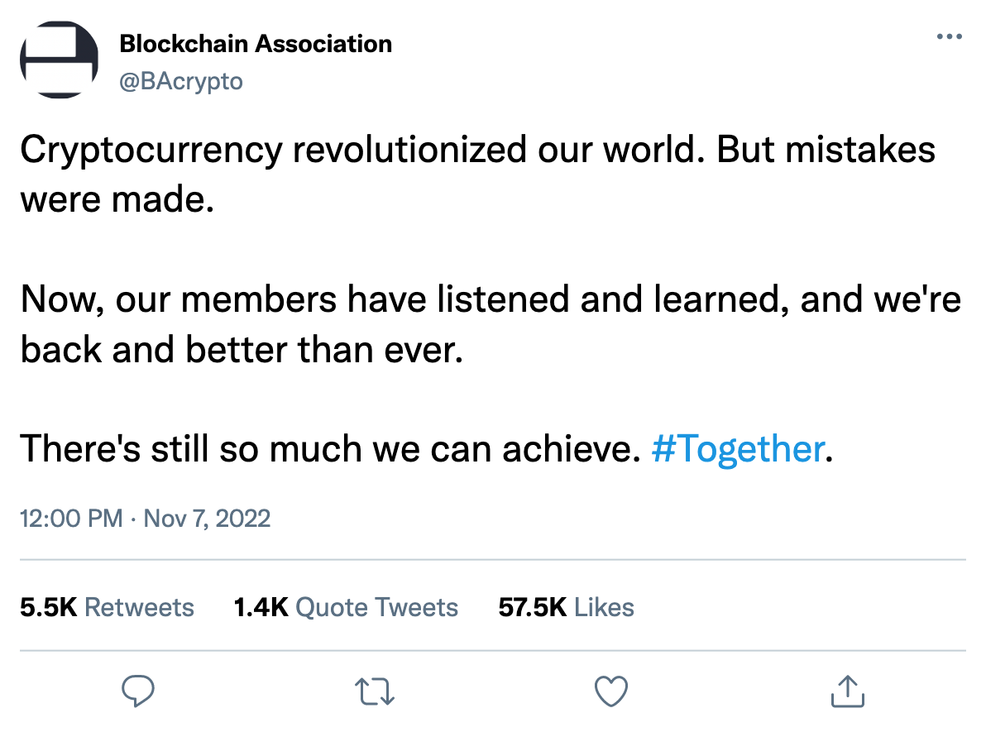
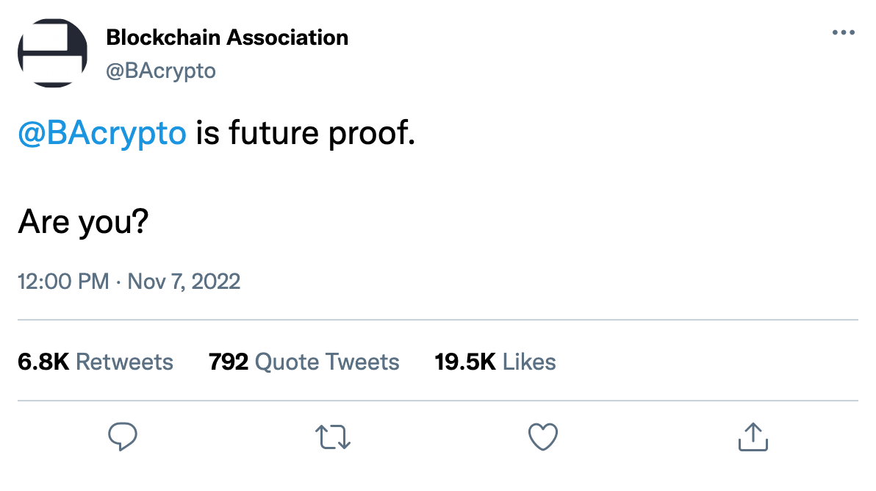

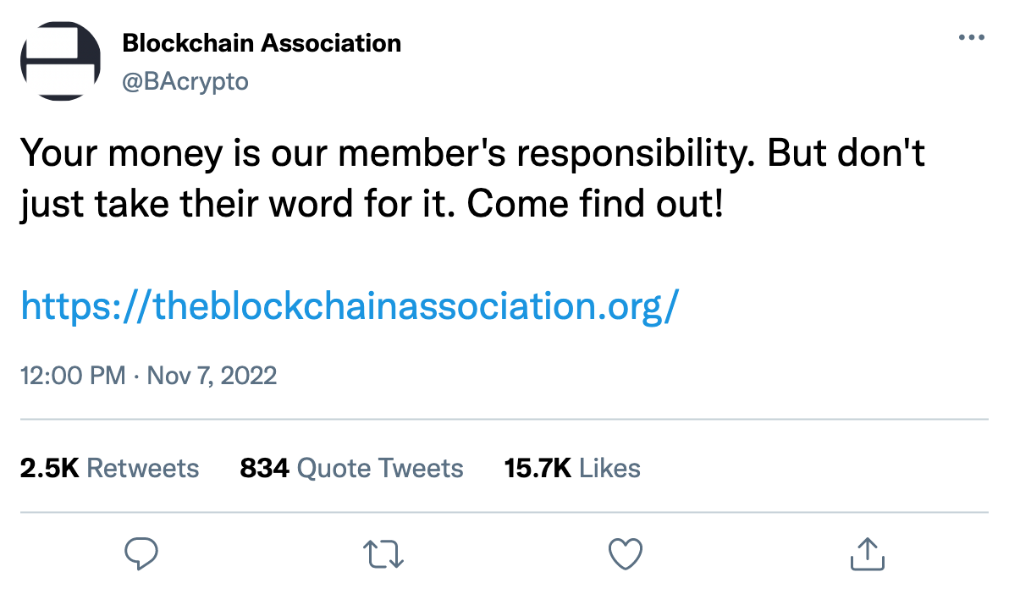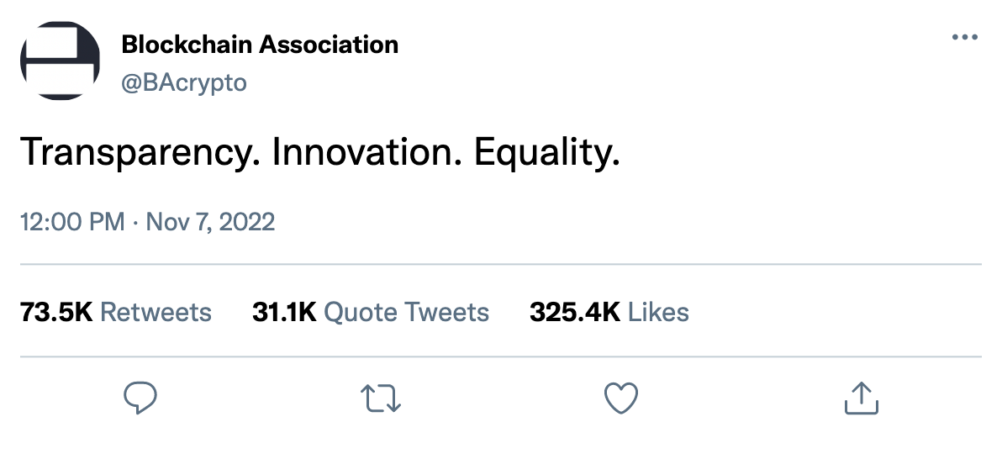

----------

Conclusion
The Blockchain Association has sought Peters Communications counsel on repairing the reputational damage the cryptocurrency industry has sustained due to the recent intense crisis surrounding FTX and subsequent well-publicized scrutiny of the company’s disintegration in the media. This communications response plan offers several recommendations designed to stem the flow of reputationally damaging information, prevent further credibility hemorrhaging and postpone and prepare for any future oversight and investigation from the public, Congress, industry and financial regulators, and a broad array of stakeholders, with the eventual aim of sustainability and renewal. Effectively utilizing the variety of specific, concrete tactical actions prescribed in this plan alongside consistent communications on traditional and social media in line with our strategic imperatives will be vital in the following days and weeks as The Blockchain Association looks to stabilize and restore the cryptocurrency industry’s reputation amid recent debilitating credibility crises and provides substantive action steps to win back the trust of key stakeholders. If successful, the reputation damage suffered thus far will pale into insignificance, given the long-term image enhancement the cryptocurrency industry will experience. Peters Communications believes the future is bright for the Blockchain Association, and we look forward to working with you on this reputational recovery project with the eventual goal of growing your membership and accentuating your role as a thought leader and dominant force in the cryptocurrency industry. We propose that we meet with your team early next week to review this plan and get to work.

